H.T No
Regulations:
A19

Sreenidhi Institute of Science and Technology
(An Autonomous Institution)
Code No: 7X211 Date: 28-April-2022 (FN)

M.Tech I-Year II-Semester External Examination, April/May - 2022 (Supplementary)
POWER SYSTEM STABILITY (EPE)

Time: 3 Hours Max.Marks:70

Note: a) No additional answer sheets will be provided.
b) All sub-parts of a question must be answered at one place only, otherwise it will not be valued.
c) Missing data can be assumed suitably.

ANSWER ANY 5 OUT OF 8 QUESTIONS. EACH QUESTION CARRIES 14 MARKS.

Bloom's Cognitive Levels of Learning (BCLL)

Remember | L1 | Apply | L3 | Evaluate | L5
Understand | L2 | Analyze | L4 | Create | L6

 |  |  | BCLL | CO(s) | Marks
1. | a) | Describe any two typical cases of voltage collapse incidents. | L1 | CO1 | [7M]
 | b) | Differentiate voltage stability from rotor angle stability. | L2 | CO1 | [7M]
2. |  | Explain the Newton-Raphson method for load flow studies. Explain the bus mismatches and convergence criteria. Also explain the computations that are to be carried out for PV buses with reactive power limitations. | L3 | CO2 | [14M]
3. | a) | For the simple thevenin system shown in the below figure, find an expression for P=f(V). For unity power factor load, determine the maximum power and the voltage at maximum power (critical voltage). Normalise the variables based on the S.C. power, E²/X with: p = PX/E², q = QX/E² & v = V/E.  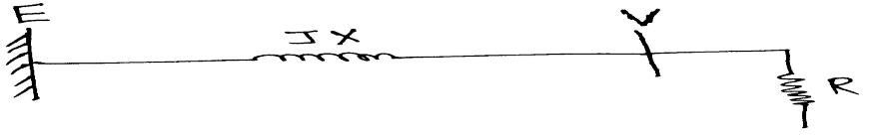 | L4 | CO3 | [7M]
 | b) | Write about analysis of voltage stability using QV-curves. Draw a family of QV-curves for various constant real power values. | L5 | CO3 | [7M]
4. | a) | Briefly describe about “Exciter Model” used in power system transient stability studies. | L2 | CO4 | [7M]
 | b) | Describe about the “Methods of Simulation” w.r.t power system stability studies. | L2 | CO4 | [7M]
5. |  | Draw a neat diagram of “generator connected through transmission line to infinite bus system” and explain the single-machine-to-infinite bus system model used in transient stability studies. | L1 | CO5 | [14M]
6. | a) | State the system parameters which affect transient stability. Explain the effect of these parameters on transient stability. | L4 | CO6 | [7M]
 | b) | Explain the effects of “excitation and prime-mover control” with respect to system design for transient stability of power system. | L5 | CO6 | [7M]
7. | a) | List out few voltage instability incidents which lead to voltage collapse. | L3 | CO1 | [5M]
 | b) | Describe what is transient voltage instability? | L1 | CO2 | [5M]
 | c) | Draw the profile of critical receiving end voltage at different power factors for varying power angle. | L2 | CO3 | [4M]
8. | a) | Write about the “tie line oscillations” in a power system. | L1 | CO4 | [5M]
 | b) | Draw a suitable figure to include potential energy curve and phase plane trajectory to explain and illustrate transient instability. | L4 | CO5 | [5M]
 | c) | List the advantages of series connected dynamic brake. | L5 | CO6 | [4M]

-- 00 -- 00 –

